Confirmation Retreat

Each candidate must attend a Confirmation Retreat. This retreat is requirement from the Bishop of the Diocese of Green Bay. Any conflict with the retreat date and time must be brought to the attention of the Confirmation Coordinator.

When? Sunday, May 13, 2026, at 9:30am- 6:00 pm

Where? Mt. Tabor Retreat Center: 522 2nd St, Menasha, WI 54952
(920) 722-8918

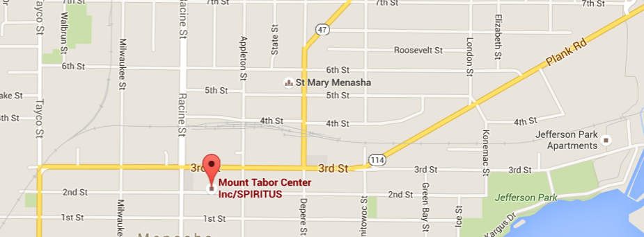

One- Day Retreat
May 13, 2026, 9:30am-6:00pm
Mount Tabor Center,522 2nd St. Menasha,
WI 54952, USA

Frequently Asked Questions
- Where is the retreat being held?
In-person retreats will be at Mount Tabor Center
- How do I know I am registered for this retreat?
You will receive an email confirming your registration.
- How do I get to the retreat?
Students are responsible for their own transportation to
and from Mount Tabor Center. Free parking is available
- What should I bring with me?
An open heart.
- Electronic devices are not permitted on retreat.
Students are asked to set aside cell phones and electronic devices for the duration of the retreat. SPIRITUS Missionaries will collect devices at the beginning of the retreat and return them when the retreat is completed.

- How can I be reached during retreat?
In the event of an emergency, your family can reach you at this number: (920) 385-1576
-- day of retreat ONLY –
- Should I bring food with me?
All meals are provided by Mount Tabor Center.
You can bring a snack if you wish.
All food and beverages must be kept in either the kitchen or dining room.
- What if I have dietary restrictions?
Gluten-free bread, peanut butter and jelly are available at every meal.
If you have special dietary restrictions, feel free to bring food with you.
A kitchen is available for storing food items.
- Will I be attending Sunday Mass during the retreat?
Yes, Mass will be part of your retreat.
- Where can I park?
PARKING
There is a parking lot on the west side of the building you may use.
Parking on the street is allowed during the daytime hours.

